Lab 4 Report: A* Search and Heuristics
Repository URL: [add your GitHub URL] Final commit identifier: [add output of git rev-parse HEAD]

1. Problem and Assumptions
The problem is to find the cheapest route from S to G on the supplied campus graph using A* with the supplied heuristic, to compare it with uniform-cost search (UCS, which is A* with h = 0), and to test what happens when one heuristic value is made an overestimate.
Supplied graph (hand-drawn). Edge costs are written on the lines and the heuristic value h is written next to each node:
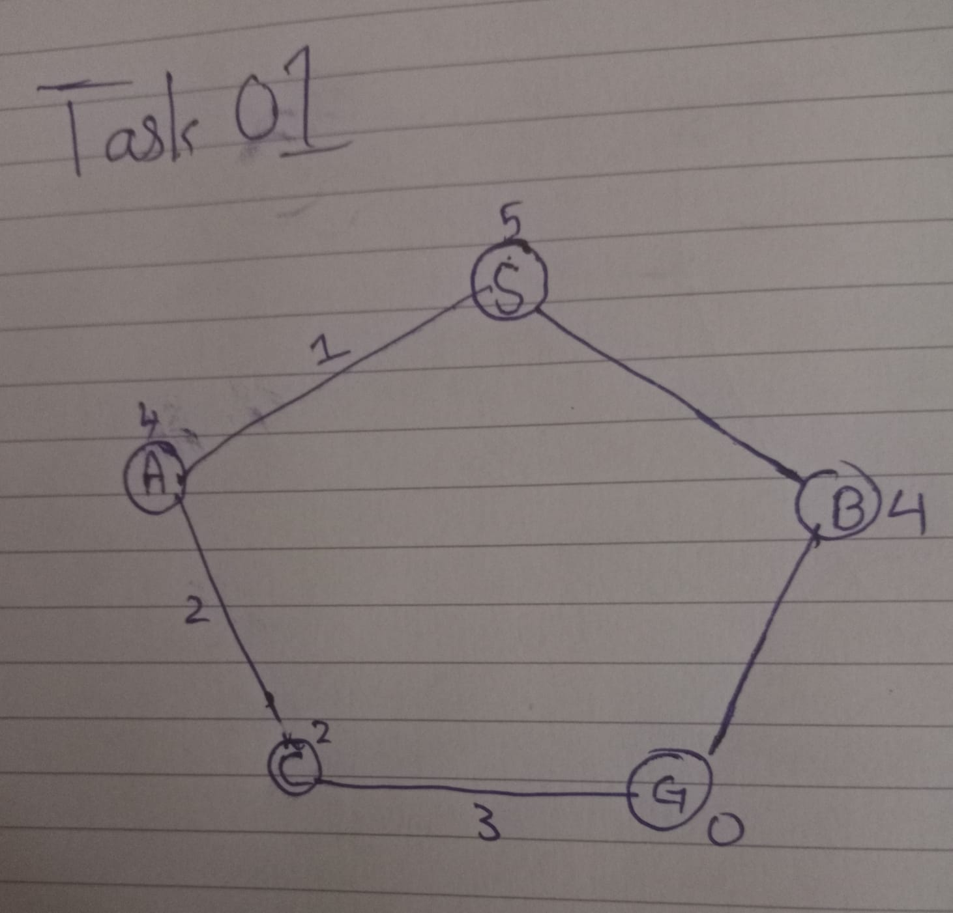
Edge | Cost
S – A | 1
S – B | 4
A – C | 2
B – G | 5
C – G | 3

Node | h(n) | True remaining cost h*(n) | Route for h*(n)
S | 5 | 6 | S-A-C-G
A | 4 | 5 | A-C-G
B | 4 | 5 | B-G
C | 2 | 3 | C-G
G | 0 | 0 | (goal)

Assumptions:
- The costs and h values were read from the handwritten drawing. If any was misread, correct it in lab4_graph.py and re-run; the traces below would then need to be redone.
- The drawing has no arrows, so corridors are two-way. Successors are tried in the order S: A, B; A: S, C; B: S, G; C: A, G.
- Queue order: lowest f = g + h first. Ties are broken by insertion order (first in, first out). No tie occurred in the frontier in these runs.
- The goal is tested when a node is taken off the frontier. A node that was already expanded is skipped as stale (it is not expanded again).
- Counting convention (same for both runs): the expansion count is the number of nodes taken off the frontier and expanded, including the goal when it is taken off. The count without the goal is also given.
Heuristic check: every h(n) is at most the true remaining cost h*(n) (5 ≤ 6, 4 ≤ 5, 4 ≤ 5, 2 ≤ 3, 0 ≤ 0), so the heuristic is admissible. It is also consistent: for every edge, h(n) ≤ cost + h(n'), for example h(A) = 4 ≤ 2 + h(C) = 4.

2. Task 1: First Three A* Expansions by Hand
Each node's f is computed as f = g + h, where g is the cost from S along the path and h is the supplied heuristic.

Expansion 1: S
Item | Value
Frontier before selecting | S: g = 0, h = 5, f = 0 + 5 = 5
Selected node | S, with g = 0, h = 5, f = 0 + 5 = 5
Why selected | It is the only entry in the frontier.
Successors (in order) | A: g = 0 + 1 = 1, h = 4, f = 1 + 4 = 5  B: g = 0 + 4 = 4, h = 4, f = 4 + 4 = 8
Remaining frontier | S-A: g = 1, h = 4, f = 5  S-B: g = 4, h = 4, f = 8
Next node | A, because f = 5 is lower than B's f = 8.

Expansion 2: A
Item | Value
Frontier before selecting | S-A: g = 1, h = 4, f = 1 + 4 = 5  S-B: g = 4, h = 4, f = 4 + 4 = 8
Selected node | A, with g = 1, h = 4, f = 1 + 4 = 5
Why selected | Lowest f in the frontier (5 < 8).
Successors (in order) | S: already expanded, skipped (it would cost g = 1 + 1 = 2, but S is closed)  C: g = 1 + 2 = 3, h = 2, f = 3 + 2 = 5
Remaining frontier | S-A-C: g = 3, h = 2, f = 5  S-B: g = 4, h = 4, f = 8
Next node | C, because f = 5 is lower than B's f = 8.

Expansion 3: C
Item | Value
Frontier before selecting | S-A-C: g = 3, h = 2, f = 3 + 2 = 5  S-B: g = 4, h = 4, f = 4 + 4 = 8
Selected node | C, with g = 3, h = 2, f = 3 + 2 = 5
Why selected | Lowest f in the frontier (5 < 8).
Successors (in order) | A: already expanded, skipped  G: g = 3 + 3 = 6, h = 0, f = 6 + 0 = 6
Remaining frontier | S-A-C-G: g = 6, h = 0, f = 6  S-B: g = 4, h = 4, f = 8
Next node | G, because f = 6 is lower than B's f = 8. G is the goal, so the search stops.

The hand calculations match the program trace in outputs/astar_ucs_output.txt line for line.

3. Task 2: A* and UCS Control
Both runs use the same graph, start, goal, successor order, tie-breaking and counting convention. The UCS control is the same program with h = 0 for every node, so f = g.
 | A* (supplied h) | UCS control (h = 0)
Returned path | S-A-C-G | S-A-C-G
Cost from the search | 6 | 6
Cost summed separately | 1 + 2 + 3 = 6 | 1 + 2 + 3 = 6
Processing order | S, A, C, G | S, A, C, B, G
Expansions (goal counted) | 4 | 5
Expansions (goal not counted) | 3 | 4
Stale entries popped | 0 | 0
Frontier entries left at the end | S-B (f = 8) | S-B-G (f = 9)

3.1 A* trace (g + h = f)
Step | Pop | g, h, f | Frontier after
1 | S | 0, 5, 0 + 5 = 5 | [S-A (5), S-B (8)]
2 | A | 1, 4, 1 + 4 = 5 | [S-A-C (5), S-B (8)]
3 | C | 3, 2, 3 + 2 = 5 | [S-A-C-G (6), S-B (8)]
4 | G (goal) | 6, 0, 6 + 0 = 6 | [S-B (8)]

3.2 UCS control trace (h = 0, so f = g)
Step | Pop | g, h, f | Frontier after
1 | S | 0, 0, 0 | [S-A (1), S-B (4)]
2 | A | 1, 0, 1 | [S-A-C (3), S-B (4)]
3 | C | 3, 0, 3 | [S-B (4), S-A-C-G (6)]
4 | B | 4, 0, 4 | [S-A-C-G (6), S-B-G (9)]
5 | G (goal) | 6, 0, 6 | [S-B-G (9)]

3.3 Explanation of the differences
- Same answer, different effort: both runs return S-A-C-G at cost 6, so the heuristic did not change the answer, only the work. A* expanded 4 nodes and UCS expanded 5.
- Why A* skipped B: A* ranks B by f(B) = 4 + 4 = 8, which is higher than 6, so G (f = 6) is taken first. UCS ranks B only by g(B) = 4, which is lower than G's g = 6, so it expands B before G even though B leads to a worse route.
- Stale and duplicate entries: no stale entry was ever taken off the frontier in either run (count 0). UCS did create a second entry for G, S-B-G at cost 9, when it expanded B. It stays in the frontier and is never taken, because the cheaper entry S-A-C-G is taken first. A* never expanded B, so it never created that duplicate; its leftover entry is the unexpanded S-B.
- Goal counting: the goal is counted when it is taken off the frontier, in both runs. Without it the counts are 3 and 4. The difference between the algorithms is 1 expansion either way.

4. Task 3: Overestimating One Heuristic Value
Only h(C) was changed. The true remaining cost from C to G is 3 (the direct corridor C–G), found with h = 0.
Value | h(C) | Comparison with the true remaining cost 3
Original | 2 | Underestimate by 1 (admissible)
Modified | 10 | Overestimate by 7 (not admissible)

Run | Path and cost | Processing order | Frontier at the end
Original h(C) = 2 | S-A-C-G, 6 | S, A, C, G (4) | S-B (f = 8)
Modified h(C) = 10 | S-B-G, 4 + 5 = 9 | S, A, B, G (4) | S-A-C (f = 3 + 10 = 13)

Result: the path and cost changed. The cost went from 6 to 9, which is not optimal. The expansion count stayed at 4, but the expanded nodes are different (B replaced C).
Modified trace: after expanding A, C enters the frontier with f = 3 + 10 = 13, so B (f = 8) is expanded next and creates G with g = 4 + 5 = 9, f = 9. G (f = 9) is lower than C (f = 13), so G is taken off first and the search stops at the goal with cost 9.

4.1 Why an overestimate removes the optimality guarantee
A* is optimal when h never overestimates, because then f = g + h is a lower bound on the cost of any route through a node. A node on the best route can never look worse than the best route's real cost, so it is always taken off before a worse goal entry. An overestimate breaks this lower bound: f(C) = 13 is larger than the true cost 6 of the route through C, so C is pushed behind B and the more expensive goal entry S-B-G (f = 9) wins.
An overestimate does not always change a particular run. The table below changes only h(C) each time. For h(C) = 4, 5 and 6 the heuristic overestimates (true cost 3), yet the returned path is still optimal, because f(C) = 3 + h(C) stays at or below 9, the cost of the alternative S-B-G route. At h(C) = 5 and 6 B was expanded as well, so the work changed. Only from h(C) = 7 (f = 10 > 9) does the result change. So a run that looks fine does not prove the heuristic is safe; the guarantee needs the property h ≤ true cost for every node, not just a lucky graph.
h(C) | Path | Cost | Processing order
2 (original) | S-A-C-G | 6 | S, A, C, G
3 (exact) | S-A-C-G | 6 | S, A, C, G
4 | S-A-C-G | 6 | S, A, C, G
5 | S-A-C-G | 6 | S, A, B, C, G
6 | S-A-C-G | 6 | S, A, B, C, G
7 | S-B-G | 9 | S, A, B, G
10 (required example) | S-B-G | 9 | S, A, B, G

5. Edge Case Analysis: The Overestimate
Input: the supplied graph with h(C) changed from 2 to 10, start S, goal G.
Observed behavior: A* returned S-B-G with cost 9 instead of S-A-C-G with cost 6, and its expansion count stayed at 4.
Likely cause: h(C) = 10 is larger than the true remaining cost 3, so f(C) = 13 is larger than the cost of the goal entry S-B-G (f = 9), and A* took the goal entry first.
Proposed improvement: keep the heuristic admissible by lowering h(C) to at most 3, and check h(n) ≤ true remaining cost for every node (easy on a small graph by running UCS from each node). This check was done for the original heuristic by hand and is implemented for node C only in lab4_overestimate.py.

6. Limitations
- The graph and heuristic values were read from a handwritten drawing; a misread value would change the traces.
- The graph is tiny, with one alternative route, so the results show behaviour on one example and say little about large graphs.
- No frontier tie occurred, so the tie-breaking rule (first in, first out) was stated but not exercised.
- Only one node's heuristic was modified; other nodes could behave differently.
- Expansion counts measure nodes taken off the frontier, not running time or memory.

7. Reflection
Doing the first three expansions by hand showed that A* is UCS with a different ordering key, and that the heuristic saved one expansion (B) here. The most useful experiment was changing h(C): it showed that an unsafe heuristic can sometimes still return the right answer, so one good run is weak evidence. Next time I would test a graph with tied f values.

